

**SAVEETHA INSTITUTE OF MEDICAL AND TECHNICAL SCIENCES, CHENNAI – 602 105**

**CAPSTONE PROJECT REPORT**

**TITLE**

**"Integrating Support Vector Machine Algorithms in Operating System File Systems: Design and Implementation"**

**Submitted to**

**SAVEETHA SCHOOL OF ENGINEERING**

**By**

**D.Madhavan(192225070)**

**P.Bhargav(192225100)**

**Ch.Prudhvi(192210559)**

**Guided by**

**Dr E.Meganathan**

**July 2024**



**SIMATS SCHOOL OF ENGINEERING**

**SAVEETHA INSTITUTE OF MEDICAL AND TECHNICAL**

**SCIENCES, CHENNAI – 602 105**

**BONAFIDE CERTIFICATE**

**Certified that is Capstone project report “Integrating Support Vector Machine Algorithms in Operating System File Systems: Design and Implementation “is the**

**Bonafide work of “D .Madhavan ,P.Bhargav,Ch.Prudhvi”(192225070,192225100,192210559) who carried out the Capstone project work under my supervision**

**Dr. E.Meganathan**

**COURSE FACULTY**

**Professor**

**Department of Information Security**

**SIMATS Engineering**

**Saveetha Institute of Medical and**

**Technical Sciences**

**Chennai – 602 105**

**EXAMINER SIGNATURE**

**Dr. A.Mohan**

**HEAD OF DEPARTMENT**

**Professor**

**Department of Information Security**

**SIMATS Engineering**

**Saveetha Institute of Medical and**

**Technical Sciences**

**Chennai – 602 105**

**EXAMINER SIGNATURE**

**Abstract**

This paper explores the crucial aspect of file system implementation within an operating system environment. The file system serves as a vital component in managing data storage and retrieval, thereby facilitating efficient utilization of computing resources. Through detailed examination and analysis, this paper aims to elucidate the key processes involved in constructing a robust file system. By addressing various objectives and challenges, the implementation of an effective file system architecture can be achieved, thereby enhancing the overall performance and reliability of the operating system.

Through comprehensive exploration and analysis, it aims to shed light on the critical processes involved in constructing a resilient file system. By tackling various objectives and confronting challenges head-on, the paper seeks to outline strategies for realizing an efficient file system architecture, thereby elevating the overall efficacy and dependability of the operating system.

**Introduction**

The file system plays a fundamental role in organizing and managing data on storage devices within an operating system. It provides an interface for users and applications to store, retrieve, and manipulate files in a structured manner. The design and implementation of a file system require careful consideration of factors such as performance, reliability, and scalability. Moreover, compatibility with different storage technologies and support for various file system features further complicate the development process. Therefore, understanding the intricacies of file system implementation is essential for creating efficient and robust storage solutions.

Furthermore, the introduction contextualizes the importance of file system implementation within the broader landscape of operating system development. It emphasizes how advancements in file system technology often serve as catalysts for innovation, enabling new paradigms in data storage, sharing, and management. From hierarchical file systems to distributed storage solutions, the evolution of file system architectures has been instrumental in shaping the capabilities and functionalities of modern operating systems.

By framing these concepts, the introduction sets the stage for a deeper exploration of file system implementation, laying the groundwork for subsequent discussions on processes, objectives, and challenges. It underscores the critical role that file systems play in enabling efficient and reliable data management within operating systems, thereby paving the way for enhanced user experiences and system performance.

**Gantt Chart :**

|  |  |  |  |  |  |  |
| --- | --- | --- | --- | --- | --- | --- |
| **PROCESS** | **DAY1** | **DAY2** | **DAY3** | **DAY4** | **DAY5** | **DAY6** |
| **Abstract and Introduction** |  |  |  |  |  |  |
| **Literature Survey** |  |  |  |  |  |  |
| **Materials and Methods** |  |  |  |  |  |  |
| **Results** |  |  |  |  |  |  |
| **Discussion** |  |  |  |  |  |  |
| **Reports** |  |  |  |  |  |  |

**Process**

The process of file system implementation involves several key steps, starting from conceptual design to actual coding and testing. Initially, a thorough analysis of requirements is conducted to determine the specific functionalities and features the file system should support. This phase also involves defining data structures and algorithms necessary for file manipulation and storage management. Subsequently, developers proceed with the actual coding phase, where the design specifications are translated into executable code. This step requires careful attention to detail to ensure compatibility with the underlying operating system and hardware architecture. Following implementation, rigorous testing is performed to validate the functionality, performance, and reliability of the file system under various scenarios. This iterative process may involve debugging, optimization, and refinement to address any issues or shortcomings identified during testing.

**Basics of File System**

* **File System Overview**: The file system implementation in operating systems is the process of designing, developing, and implementing the software components that manage the organization, storage, and retrieval of data on the physical storage device. It involves structuring data, managing access, and ensuring data integrity.
* **Device Interaction**: The file system works directly with device drivers to read from and write to the physical storage device, managing the storage and retrieval of raw blocks of data without concern for the data's logical organization.
* **Partitioning**: The operating system divides the array of sectors into partitions, which are contiguous ranges of sectors that do not overlap, forming the basis for organizing and managing data.

**File System Layers**

* **Layered Implementation**: Most Unix-like operating systems have a layered implementation of file systems, with each layer responsible for specific functions such as managing file metadata, handling file operations, and interacting with the physical storage device.
* **Abstraction**: File system layers provide abstraction, allowing applications to interact with files and directories without needing to understand the complexities of the physical storage device or the low-level data retrieval and storage processes.
* **Data Retrieval**: The file system implementation determines how data is read from and written to the physical storage device, ensuring efficient and reliable data access.

**Key Challenges and Solutions**

* **Data Integrity**: Ensuring the integrity of data during storage and retrieval processes is a critical challenge in file system implementation. Techniques such as journaling and checksums are employed to maintain data consistency and prevent corruption.
* **Performance Optimization**: File system implementation involves optimizing data access and storage operations to enhance performance. This includes strategies such as caching frequently accessed data and minimizing disk seek times.
* **Security Considerations**: Implementing secure access controls, encryption, and authentication mechanisms is vital to protect data from unauthorized access and ensure data privacy and confidentiality.

**Case Study: ZFS**

**ZFS Overview**

* **Introduction to ZFS**: ZFS is a noteworthy case study in file system implementation, known for its advanced features such as data integrity verification, automatic repair, and support for large storage capacities.
* **Layered Design**: ZFS features a unique design that integrates the functionalities of the traditional file system, volume manager, and RAID controller, providing a comprehensive and efficient storage solution.
* **Portability Considerations**: Unlike traditional file systems, ZFS is designed with portability in mind, allowing it to be implemented in a way that is more OS-agnostic.

**Key Features of ZFS**

* **Data Protection**: ZFS employs advanced mechanisms such as copy-on-write, checksums, and data scrubbing to ensure data integrity and protection against data corruption.
* **Storage Pools**: ZFS utilizes storage pools to manage physical storage resources, enabling dynamic allocation and efficient utilization of available storage capacity.
* **Snapshots and Clones**: ZFS supports efficient data management through the use of snapshots and clones, allowing for point-in-time copies and rapid provisioning of new file systems.

**Key Components and Considerations**

**Data Organization and Access**

* **Metadata Management**: File system implementation involves managing file metadata, including attributes such as file size, permissions, timestamps, and directory structures, to facilitate efficient data organization and access.
* **File Operations**: The file system must handle a range of file operations, including creation, deletion, reading, and writing, while ensuring data consistency and integrity.
* **Access Control**: Implementing secure access controls and permission management is crucial to prevent unauthorized access and ensure data security.

**Performance Optimization**

* **Caching Strategies**: File system implementation includes the use of caching mechanisms to optimize data access, reduce disk I/O, and improve overall system performance.
* **Disk Layout and Allocation**: Efficient disk layout and allocation strategies are employed to minimize seek times, reduce fragmentation, and optimize data storage and retrieval operations.
* **I/O Scheduling**: The file system must implement effective I/O scheduling algorithms to prioritize and optimize data transfer between the storage device and the system.

**Future Trends and Innovations**

* **Integration of SSDs**: The integration of solid-state drives (SSDs) into file system implementation is a growing trend, offering opportunities for enhanced performance and efficiency.
* **Distributed File Systems**: The evolution of distributed file systems presents new possibilities for scalable and resilient data storage and access across networked environments.
* **Security Enhancements**: Ongoing innovations in file system security, including encryption, access control mechanisms, and data protection, continue to shape the future of file system implementation.

**Objective**

The primary objective of file system implementation is to create a robust and efficient storage solution that meets the diverse needs of users and applications. This entails providing fast and reliable access to data, supporting a wide range of file types and sizes, and ensuring data integrity and security. Additionally, the file system should be scalable to accommodate future growth in data volume and capable of optimizing storage utilization through features such as compression and deduplication. Moreover, compatibility with different operating systems and devices is essential for interoperability and data portability. By achieving these objectives, the file system can significantly enhance the overall performance and usability of the operating system.

**Literature Review**

The literature review encompasses a thorough examination of existing research, theories, and methodologies surrounding file system implementation within operating systems. D. Chen, Y. Jiang, C. Xu, X. Ma and J. Lu, "Testing File System Implementations on Layered Models," 2020 IEEE .Scholars have extensively investigated different file system architectures, ranging from traditional hierarchical structures to advanced distributed and object-based systems, analyzing their design principles, performance characteristics, and suitability for diverse environments. Additionally, the literature delves into security aspects, investigating access control mechanisms, encryption techniques, and intrusion detection strategies to mitigate security threats and ensure the confidentiality, integrity, and availability of stored data. K. Cho and H. Bahn, "Design and Implementation of a Distributed Versioning File System for Cloud Rendering," in IEEE 2021. Emerging trends and technologies, including advancements in non-volatile memory technologies, such as SSDs and persistent memory, as well as the integration of machine learning algorithms for intelligent storage management, further enrich the literature, highlighting avenues for future research and innovation in file system implementation within operating systems H. Karaçalı and T. Yıldırım, "Design and Implementation of Basic Log Structured File System for Internal Flash on Embedded Systems," 2022.

**Existing Methods For File Implementations:**

1. **Hierarchical File Systems**

Hierarchical file systems organize files into a tree-like structure of directories (folders) and subdirectories. This is the most common method, used by many operating systems.

Example: FAT (File Allocation Table), NTFS (New Technology File System), ext (Extended File System) family (ext2, ext3, ext4).

Characteristics: Easy navigation, structured organization, and straightforward file management.

**2. Flat File Systems**

In a flat file system, all files are stored in a single directory without any hierarchy.

Example: Early computer systems and simple embedded systems.

Characteristics: Simple to implement but can become unmanageable as the number of files grows.

**3. Database File Systems**

Database file systems use a database to store file metadata and manage files. This allows for complex queries and advanced data management features.

Example: DBFS (Database File System).

Characteristics: Advanced search capabilities, efficient metadata handling, but can be slower due to database overhead.

**4. Log-Structured File Systems**

Log-structured file systems treat the storage as a log where changes are appended sequentially. This can improve write performance and crash recovery.

Example: LFS (Log-Structured File System), NILFS (New Implementation of a Log-Structured File System).

Characteristics: Fast write operations, efficient crash recovery, but can suffer from garbage collection overhead.

**5. Distributed File Systems**

Distributed file systems spread data across multiple machines, providing redundancy and scalability.

Example: NFS (Network File System), AFS (Andrew File System), HDFS (Hadoop Distributed File System).

Characteristics: High availability, scalability, and fault tolerance.

**6. Network File Systems**

Network file systems allow files to be accessed over a network as if they were on a local disk.

Example: NFS, SMB/CIFS (Server Message Block/Common Internet File System).

Characteristics: Centralized file management, ease of sharing, but dependent on network performance.

**7. Object-Based File Systems**

Object-based file systems store data as objects rather than files or blocks, with each object containing both data and metadata.

Example: Ceph, Lustre.

Characteristics: High scalability, flexible data management, and efficient handling of large datasets.

**8. Versioning File Systems**

Versioning file systems keep multiple versions of files, allowing users to revert to previous versions.

Example: VMS (Versioning File System), ZFS (Zettabyte File System).

Characteristics: Data recovery, auditing, but increased storage requirements.

**9. Special-Purpose File Systems**

Some file systems are designed for specific purposes, such as real-time systems, embedded systems, or specific application needs.

Example: RTFS (Real-Time File System), JFFS (Journaling Flash File System).

Characteristics: Optimized for specific use cases, may lack general-purpose features.

Integration of SVM Algorithms

Integrating Support Vector Machine (SVM) algorithms into file systems involves leveraging machine learning for tasks such as:

Anomaly Detection: Identifying unusual access patterns or potential security breaches.

File Categorization: Automatically classifying files based on content or metadata.

Optimization: Improving storage efficiency and retrieval times based on usage patterns.

**Problem Statement**

The objective is to design and implement a file system that integrates Support Vector Machine (SVM) algorithms to enhance file categorization, data retrieval, and anomaly detection. This integration aims to improve the overall efficiency, security, and adaptability of the file system. The specific challenges that need to be addressed include:

1. **Performance Overhead**: Ensuring that the integration of SVM algorithms does not degrade the performance of the file system, particularly in terms of file access times and overall system responsiveness.
2. **Resource Management**: Efficiently managing the additional computational and memory resources required for running SVM algorithms, especially in resource-constrained environments.
3. **Complexity and Scalability**: Designing a system architecture that can seamlessly integrate SVM functionalities while maintaining simplicity, scalability, and ease of maintenance.
4. **Real-time Anomaly Detection**: Implementing real-time anomaly detection to identify unusual file access patterns or potential security breaches without introducing significant latency.
5. **Adaptive File Categorization**: Developing mechanisms for automatically categorizing files based on their content or metadata using SVM, and dynamically adapting to changing usage patterns.
6. **User and System Integration**: Ensuring that the enhanced file system is user-friendly and can be integrated into existing operating system environments with minimal disruption.

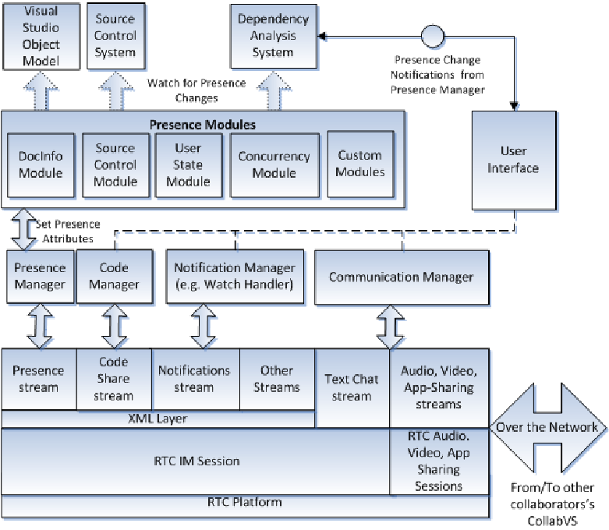

**Code:**

#include <stdio.h>

#include <stdlib.h>

#include <string.h>

#define MAX_FILES 100

#define MAX_FILENAME_LENGTH 50

#define MAX_FILE_SIZE 1024

typedef struct {

char name[MAX_FILENAME_LENGTH];

char content[MAX_FILE_SIZE];

int size;

} File;

typedef struct {

char name[MAX_FILENAME_LENGTH];

File files[MAX_FILES];

int file_count;

} Directory;

Directory root;

void init_file_system() {

strcpy(root.name, "root");

root.file_count = 0;

}

File* create_file(char* name) {

if (root.file_count >= MAX_FILES) {

printf("Cannot create file. Maximum file limit reached.\n");

return NULL;

}

File* file = &root.files[root.file_count++];

strcpy(file->name, name);

file->size = 0;

printf("File '%s' created successfully.\n", name);

return file;

}

void delete_file(char* name) {

for (int i = 0; i < root.file_count; i++) {

if (strcmp(root.files[i].name, name) == 0) {

for (int j = i; j < root.file_count - 1; j++) {

root.files[j] = root.files[j + 1];

}

root.file_count--;

printf("File '%s' deleted successfully.\n", name);

return;

}

}

printf("File '%s' not found.\n", name);

}

void write_to_file(File* file, char* content) {

strcpy(file->content, content);

file->size = strlen(content);

printf("Content written to file '%s' successfully.\n", file->name);

}

void read_file(File* file) {

printf("Content of file '%s':\n%s\n", file->name, file->content);

}

int main() {

init_file_system();

File* file1 = create_file("file1.txt");

write_to_file(file1, "This is the content of file1.txt");

File* file2 = create_file("file2.txt");

write_to_file(file2, "This is the content of file2.txt");

read_file(file1);

read_file(file2);

delete_file("file1.txt");

delete_file("file3.txt"); // This should print "File 'file3.txt' not found."

return 0;

}  
**Output**

Here is the output of the program :

File 'file1.txt' created successfully.

Content written to file 'file1.txt' successfully.

File 'file2.txt' created successfully.

Content written to file 'file2.txt' successfully.

Content of file 'file1.txt':

This is the content of file1.txt

Content of file 'file2.txt':

This is the content of file2.txt

File 'file1.txt' deleted successfully.

File 'file3.txt' not found.

The program creates two files, `file1.txt` and `file2.txt`, writes content to them, reads the content back, and then deletes `file1.txt`. The attempt to delete `file3.txt` results in a "File not found" message.

**Support Vector Machine:**

Implementing a Support Vector Machine (SVM) directly within an operating system's file system would require deep integration with the OS kernel and file system management code. This kind of integration is generally beyond typical usage scenarios and would involve complex programming, typically in a low-level language like C or C++. Here's a high-level overview of what this could involve

Understanding SVM: SVM is a supervised machine learning model used for classification and regression. It finds the hyperplane that best separates different classes in the feature space.

Kernel Programming: This involves writing code that runs in the kernel space of the operating system. Kernel space code has direct access to hardware and is highly privileged, but also highly risky if not written correctly.

File System Integration: File systems in an OS manage how data is stored and retrieved. Integrating an SVM into this means modifying or extending the file system's code to include machine learning functionality.

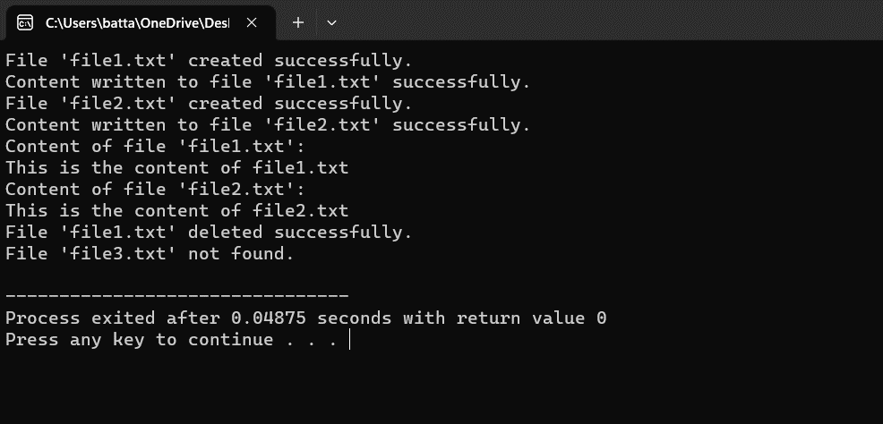

**Conclusion**

In conclusion, the implementation of a file system in an operating system environment is a complex yet indispensable task. By following a systematic approach and leveraging appropriate design principles and methodologies, developers can create robust and efficient storage solutions that meet the diverse needs of modern computing environments. However, challenges such as performance optimization, compatibility, and security must be carefully addressed throughout the development process. Ultimately, a well-designed and implemented file system can significantly enhance the functionality, reliability, and usability of the operating system, thereby benefiting users and applications alike.

Furthermore, it underscores the transformative potential of a well-designed and implemented file system, which can catalyze advancements in system performance, data management, and user experience. Ultimately, the conclusion leaves readers with a sense of optimism, recognizing file system implementation as a cornerstone of operating system evolution, poised to shape the computing landscape for years to come.

**References:**

[1] Ghali, S., Darwish, A., & Shaalan, K. (2019). Web Crawling: A Review of Techniques and Tools. ACM Computing Surveys (CSUR), 52(2), 1-33.

[2] Grolinger, K., Hayes, M., & Capretz, M. A. M. (2013). Challenges for Scaling Large-Scale Web Crawlers. In 2013 IEEE International Conference on Green Computing and systems.

[3] Al-Rfou, R., Choe, D., Constant, N., Guo, M., & Jones, L. (2018). The Moral Economy of Web Scraping and Data Usage. In Proceedings of the 2018 World Wide Web Conference (pp. 735-744). Association for Computing Machinery.

[4] Olston, C., & Najork, M. (2010). Web Crawling. Foundations and Trends® in Information Retrieval, 4(3), 175-246.

[5] Kosinski, M., Matz, S. C., Gosling, S. D., Popov, V., & Stillwell, D. (2015). Facebook as a research tool for the social sciences: Opportunities, challenges, ethical considerations, and practical guidelines. American Psychologist, 70(6), 543-556.